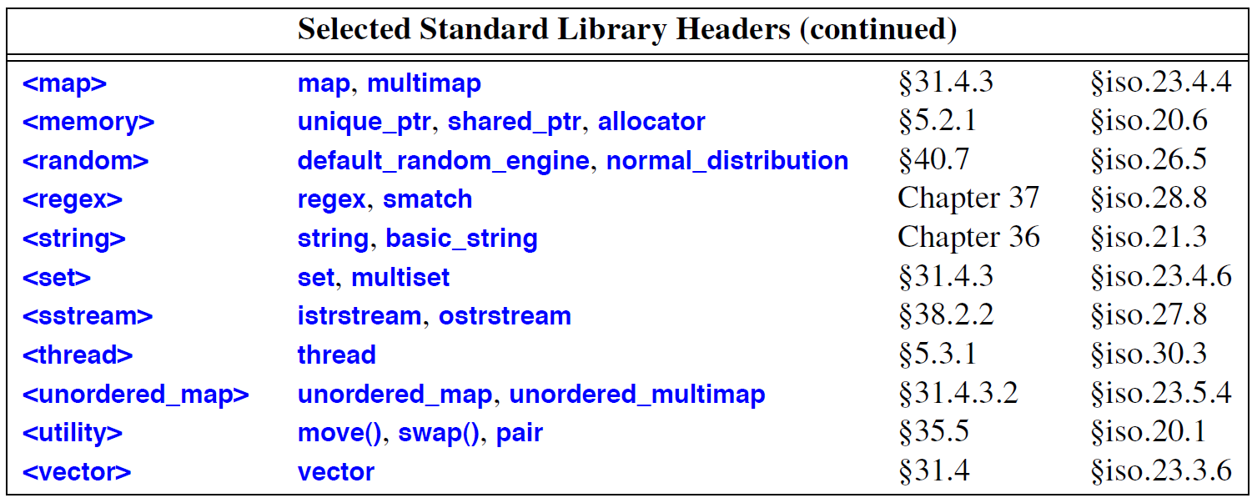

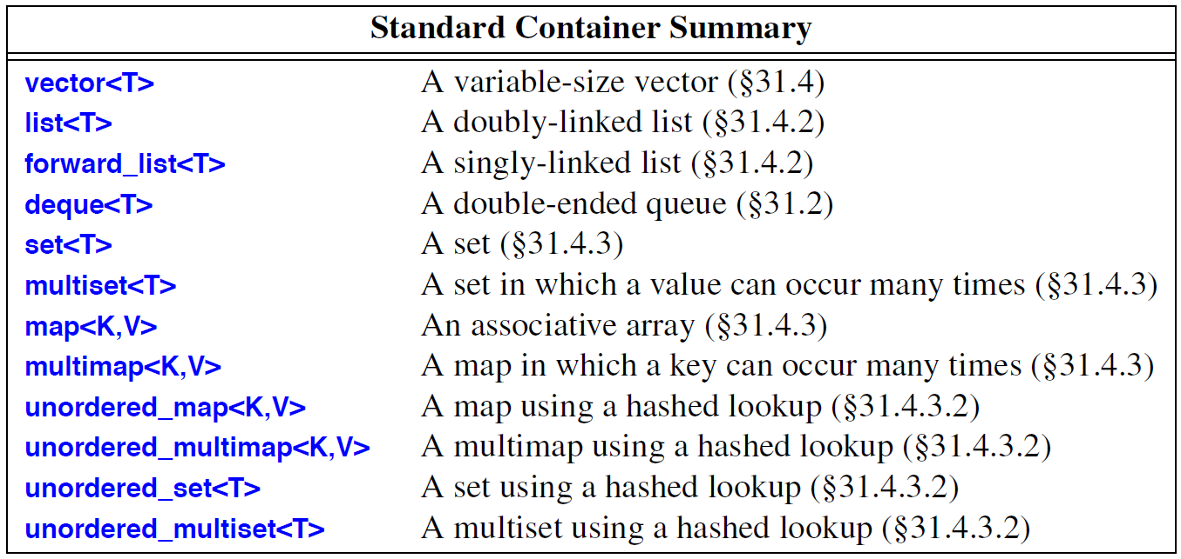

* **Algorithm:** A finite set of rules which gives a sequence of operations for solving a specific set of problems and has 5 important features –
* Finiteness
* Definiteness
* Input
* Output
* Effectiveness

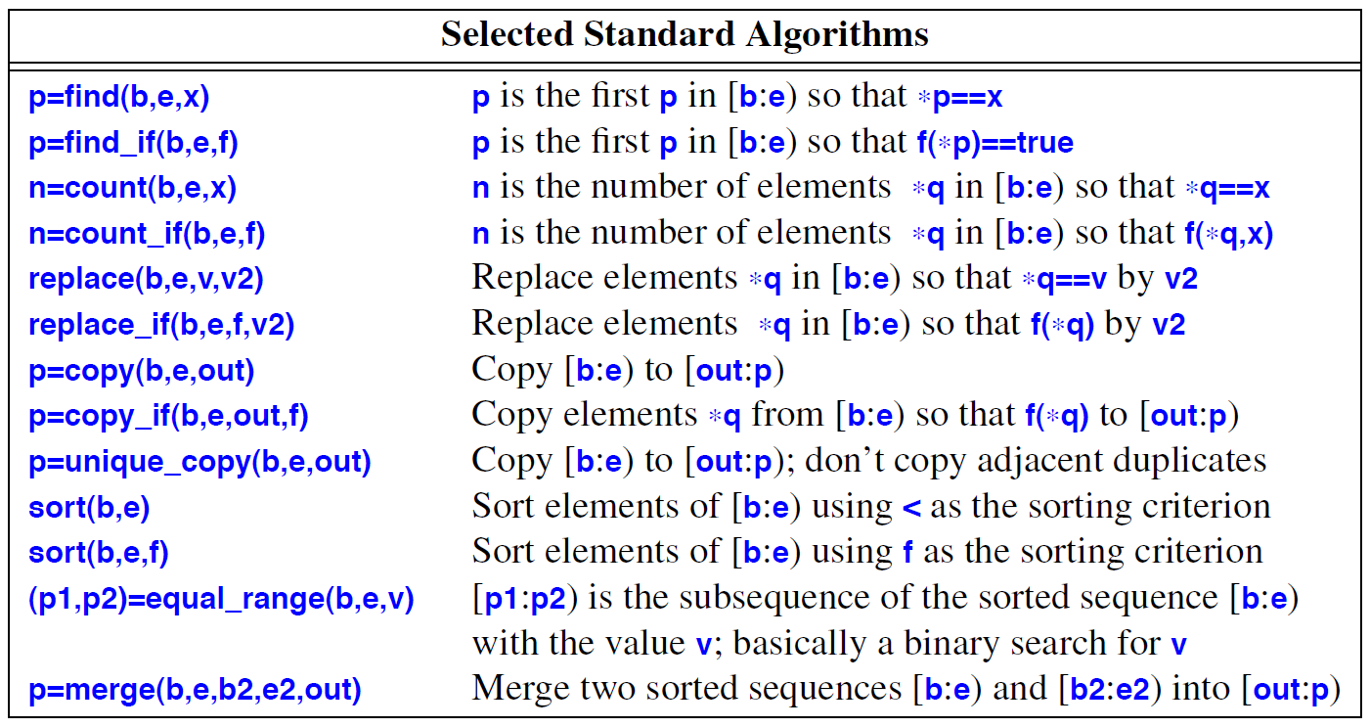

* **Advice –**
* Whenever there is a choice, prefer the standard library over other libraries.
* Do not think that the standard library is ideal for everything.
* Prefer *string*s over C-style strings, i.e. char*.
* Iostreams are type-sensitive, type-safe and extensible.
* Prefer vector<T>, map<K,T> and unordered_map<K,T> over T[].
* Know the standard containers and their trade-offs.
* Use vector as the default container.
* Prefer compact data structures.
* If in doubt, use a range-checked vector.
* Use push_back() or back_inserter() to add elements into a container.
* Use push_back() on a vector rather than realloc() on an array.
* Catch common exceptions in main().
* Know your standard algorithms and prefer them over hand-written loops.
* If iterator use gets tedious, define container algorithms.